**Experiment no #02:**

**Experiment name:**

Some basic commands on Linux Mint Operating System.

**Objective:**

1. To learn how to use basic commands on Linux Mint OS.
2. To understand the functions of those commands.

**Experimental Procedures:**

* **Terminal Emulator**

A terminal emulator is a program that allows the use of terminal in a graphical environment. As most people use an OS with a graphical user interface (GUI) for their day to day computer needs, the use of a terminal emulator is necessary for most Linux server user.

Some example of basic terminal commands are given below –

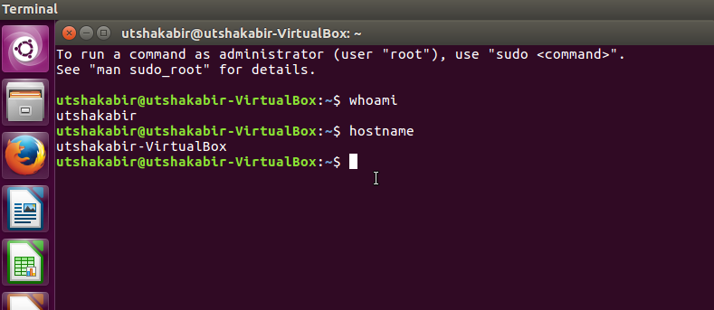

* **ls & pwd:**

“ls” lists the files in the current working folder. “pwd” prints the fully resolved name of the current (working) directory

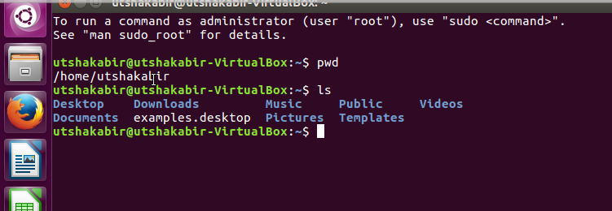

* **mkdir <dir_name> & rmdir<dir_name>:**

Folders are created with the command **mkdir. “rmdir”** is used to remove a directory from the current path

.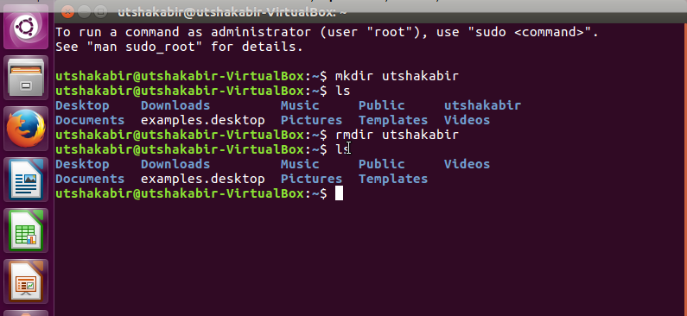

* **cd <dir_name>:**

cd stands for change (working) directory and that's what it does. It is used to change directory to a higher level or low level.

“cd ..” is used to go to root directory of the current directory.

“cd <dir_name>” is used to move to a higher directory.

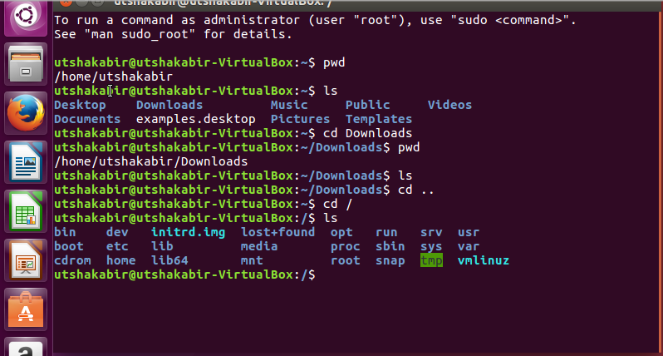

* **df & du:**

We use **du** (Disk Usage) to view how much space files and folders occupy. **df** is used to show all the size of the folders in the directory & used space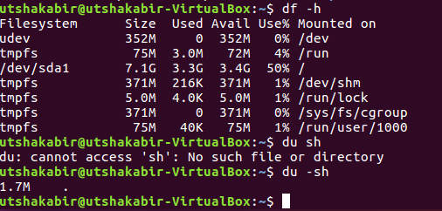

* **rm<file_name>:**

We use this command to remove a file name.

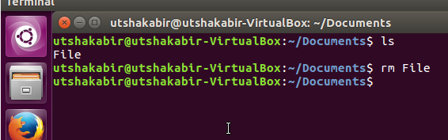

* **passwd:**

This syntax is used to change password in Linux.

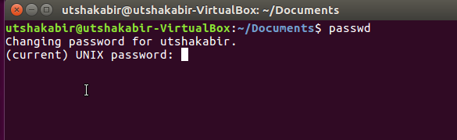

**Conclusion:**

Linux Terminal Command is Very helpful and easy to access all the Process and Working Procedure .It is an Open Free Source and Very Time Efficient ..So we can Use it to do our all Works fast and easily ..